Shawn Haman

CS-210 Programming Languages

2/16/2023

Project 3

* Summarize the project and what problem it was solving.

The project was made to develop a program to analyze the frequency, and histogram for certain food items. The problem was to create a working program to easier read these items.

* What did you do particularly well?

I believe I did a good job making sure that the code hit all the metrics the assignment asked me to do. I worked very hard to make sure I was getting the necessary help in order to fulfill each project requirement. I do very well at time management, so having 3 kids running a restaurant and going to school has been difficult but also is a huge motivator because I know I can do it.

* Where could you enhance your code? How would these improvements make your code more efficient, secure, and so on?

I could have done a better job trying to get visual studios to work, it has been a headache to me because it would have made it so much easier to get my homework turned in, instead of taking so many screen shots. Having this I believe it would have helped me to identify the problems I was having while working on this project.

* Which pieces of the code did you find most challenging to write, and how did you overcome this? What tools or resources are you adding to your support network?

The challenging part of writing my code was getting Visual studios to work for me. Since I have a Mac, it was giving me many issues. I went to the tutoring center many times, and they provided me with other compliers to help me write my code. They also helped me fix any errors I was making, when my code failed. Along with a lot of process of elimination, it gave me the proper tools to help me become a better programmer.

* What skills from this project will be particularly transferable to other projects or course work?

The skills I have learned from this project will help me in scripting for other assignments and classes. In each of my programming classes, they have taught me more and more. Not making so many minor mistakes, and I am able to faster identify where I went wrong.

* How did you make this program maintainable, readable, and adaptable?

By going to the complier its showed me where I was making mistakes, with that and a combination with the tutoring center, I made my code work efficiently giving out the proper outputs. Giving me these tools it has strengthened my skills to be able to maintain a readable program.

#include <iostream>

#include <fstream>

#include <map>

using namespace std;

class Grocer {

private:

map<string, int> items;

public:

void readFile(string fileName) {

ifstream inputFile;

inputFile.open(fileName);

if (inputFile.is_open()) {

string item;

while (inputFile >> item) {

items[item]++;

}

inputFile.close();

} else {

cout << "Unable to open file" << endl;

}

}

void writeFile(string fileName) {

ofstream outputFile;

outputFile.open(fileName);

if (outputFile.is_open()) {

for (auto const& item : items) {

outputFile << item.first << " " << item.second << endl;

}

outputFile.close();

} else {

cout << "Unable to open file" << endl;

}

}

int findItem(string item) {

if (items.count(item) > 0) {

return items[item];

} else {

return 0;

}

}

void printFrequency() {

for (auto const& item : items) {

cout << item.first << " " << item.second << endl;

}

}

void printHistogram() {

for (auto const& item : items) {

cout << item.first << " ";

for (int i = 0; i < item.second; i++) {

cout << "*";

}

cout << endl;

}

}

};

int main() {

Grocer grocer;

grocer.readFile("CS210_Project_Three_Input_File.txt");

grocer.writeFile("frequency.dat");

int choice;

string item;

do {

cout << "1. Find item frequency" << endl;

cout << "2. Print frequency of all items" << endl;

cout << "3. Print histogram of all items" << endl;

cout << "4. Exit" << endl;

cout << "Enter your choice: ";

cin >> choice;

switch (choice) {

case 1:

cout << "Enter item: ";

cin >> item;

cout << "Frequency: " << grocer.findItem(item) << endl;

break;

case 2:

grocer.printFrequency();

break;

case 3:

grocer.printHistogram();

break;

case 4:

break;

default:

cout << "Invalid choice" << endl;

break;

}

} while (choice != 4);

return 0;

}

TXT.FILE OF ITEMS

Spinach

Radishes

Broccoli

Peas

Cranberries

Broccoli

Potatoes

Cucumbers

Radishes

Cranberries

Peaches

Zucchini

Potatoes

Cranberries

Cantaloupe

Beets

Cauliflower

Cranberries

Peas

Zucchini

Peas

Onions

Potatoes

Cauliflower

Spinach

Radishes

Onions

Zucchini

Cranberries

Peaches

Yams

Zucchini

Apples

Cucumbers

Broccoli

Cranberries

Beets

Peas

Cauliflower

Potatoes

Cauliflower

Celery

Cranberries

Limes

Cranberries

Broccoli

Spinach

Broccoli

Garlic

Cauliflower

Pumpkins

Celery

Peas

Potatoes

Yams

Zucchini

Cranberries

Cantaloupe

Zucchini

Pumpkins

Cauliflower

Yams

Pears

Peaches

Apples

Zucchini

Cranberries

Zucchini

Garlic

Broccoli

Garlic

Onions

Spinach

Cucumbers

Cucumbers

Garlic

Spinach

Peaches

Cucumbers

Broccoli

Zucchini

Peas

Celery

Cucumbers

Celery

Yams

Garlic

Cucumbers

Peas

Beets

Yams

Peas

Apples

Peaches

Garlic

Celery

Garlic

Cucumbers

Garlic

Apples

Celery

Zucchini

Cucumbers

Onions

FREQUENCY OPTION 2 for ALL ITEMS

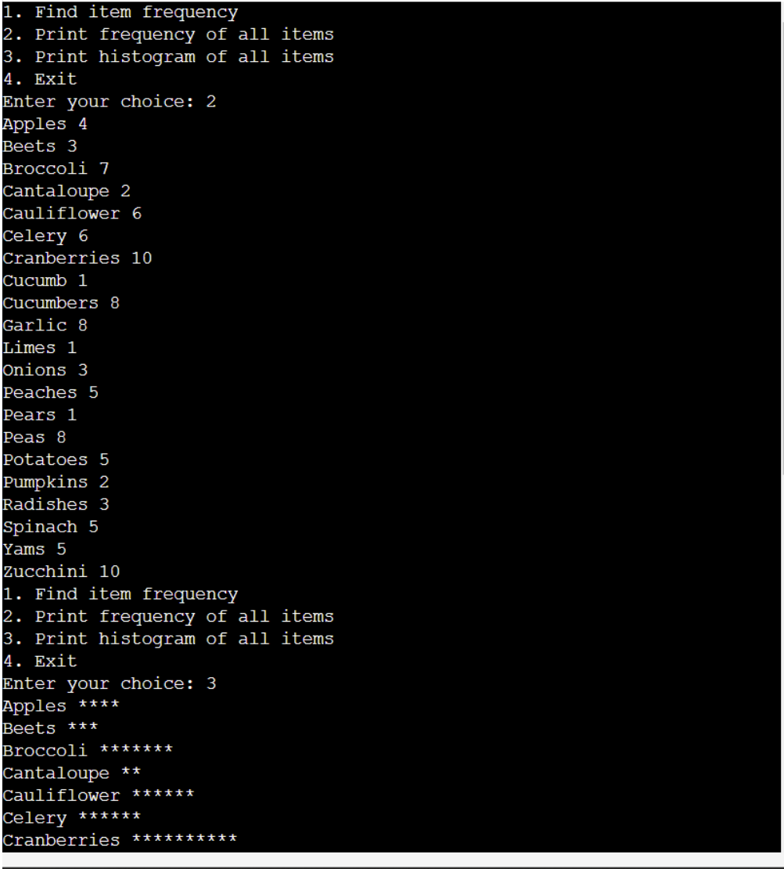

HISTOGRAM OF THE CHOICES

FREQUENCY OF TXT.FILE

ONLINE GDB COMPLIER

VISUAL STUDIOS FROM MY COMPUTER DOWNLOADED

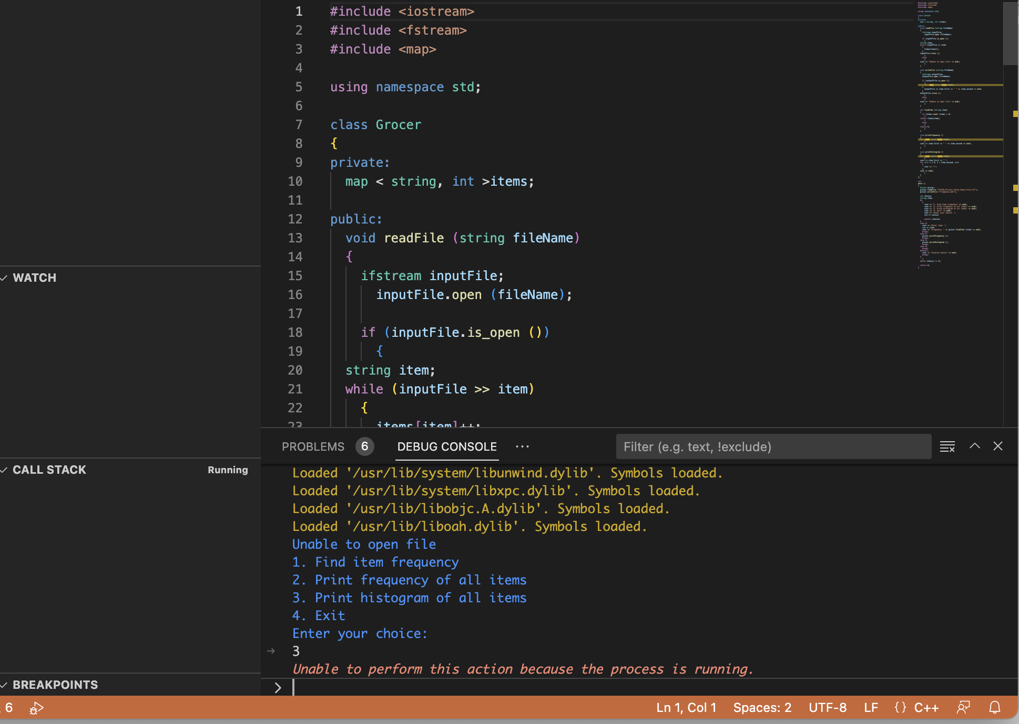

TUTORING CENTER HELPING ME OUT

ATTACHED ARE ALL THE SCREEN SHOTS THAT I HAVE DONE FOR THE PROJECT